Lab 4

Hill climbing: 4 queens

CODE:

import random

def heuristic(state):

attacks = 0

n = len(state)

for i in range(n):

for j in range(i + 1, n):

if state[i] == state[j] or abs(state[i] - state[j]) == abs(i - j):

attacks += 1

return attacks

def get_neighbors(state):

neighbors = []

n = len(state)

for col in range(n):

for row in range(n):

if row != state[col]:

new_state = state[:]

new_state[col] = row

neighbors.append(new_state)

return neighbors

def hill_climb_verbose(state):

print(f"Initial: {state} | Cost: {heuristic(state)}\n")

while True:

h_current = heuristic(state)

neighbors = get_neighbors(state)

costs = [heuristic(n) for n in neighbors]

for s, c in zip(neighbors, costs):

print(f"Neighbor: {s} | Cost: {c}")

min_cost = min(costs)

best_neighbor = neighbors[costs.index(min_cost)]

print(f"\nBest Neighbor: {best_neighbor} | Cost: {min_cost}\n")

if min_cost >= h_current:

print("Stopped: Local Minimum or Goal Reached.")

print(f"Final State: {state} | Cost: {h_current}")

break

state = best_neighbor

if heuristic(state) == 0:

print(f"✅ Goal Reached! State: {state}")

break

print("--------------------------------")

# Run with fixed start

hill_climb_verbose([0,1,2,3])

OUTPUT:  
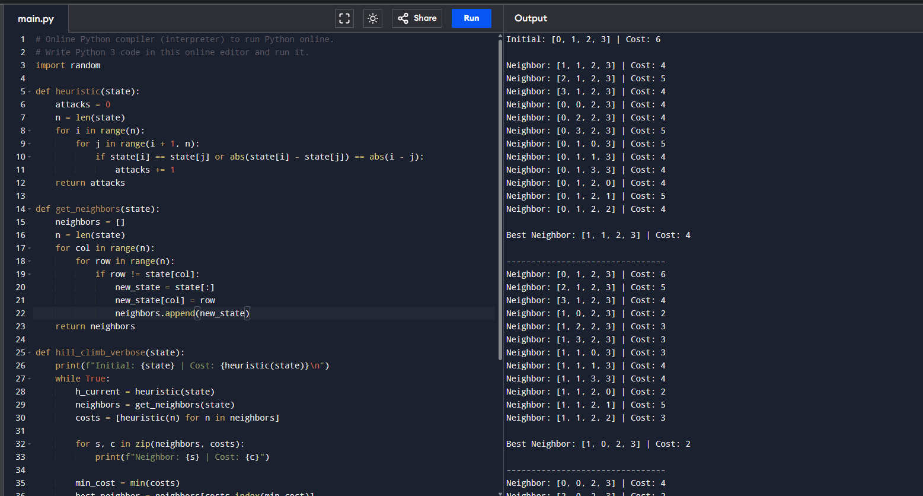

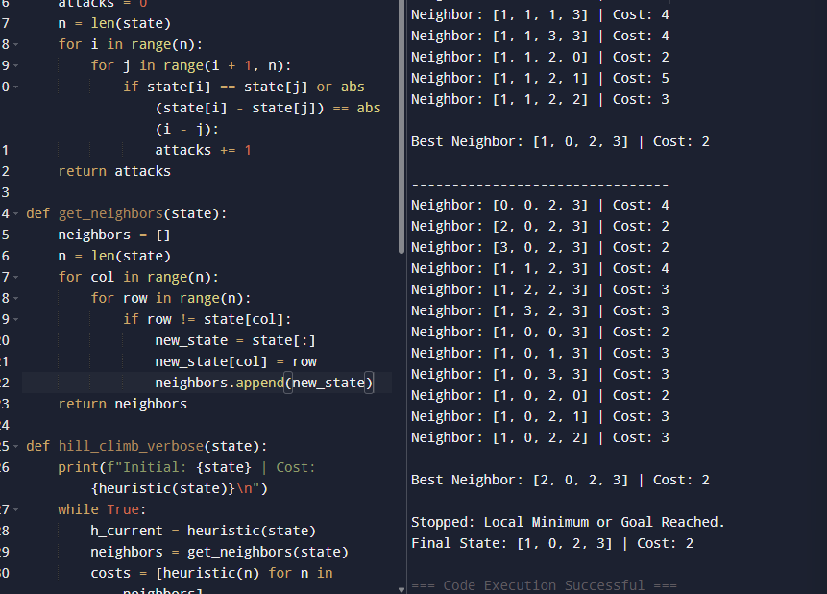

**SIMULATED ANNEALING: - 4 QUEENS**import random

import math

# Cost function: number of attacking pairs

def cost(state):

attacks = 0

n = len(state)

for i in range(n):

for j in range(i + 1, n):

if state[i] == state[j] or abs(state[i] - state[j]) == abs(i - j):

attacks += 1

return attacks

# Generate neighbor by moving one queen to a new column

def neighbor(state):

n = len(state)

new_state = state.copy()

row = random.randint(0, n - 1)

col = random.randint(0, n - 1)

while col == new_state[row]:

col = random.randint(0, n - 1)

new_state[row] = col

return new_state

# Simulated Annealing

def simulated_annealing(n=4, T=1000, alpha=0.95, max_iter=1000):

# Initial state

current = [random.randint(0, n - 1) for _ in range(n)]

current_cost = cost(current)

print(f"Initial state: {current}, cost: {current_cost}")

for i in range(max_iter):

if current_cost == 0:

print("Solution found!")

break

next_state = neighbor(current)

next_cost = cost(next_state)

print(f"Neighbor: {next_state}, cost: {next_cost}")

delta = next_cost - current_cost

if delta < 0 or random.random() < math.exp(-delta / T):

current = next_state

current_cost = next_cost

print(f"Move accepted: {current}, cost: {current_cost}")

else:

print("Move rejected")

T *= alpha # Cooling

print(f"Final state: {current}, cost: {current_cost}")

# Run

simulated_annealing()

**OUTPUT**

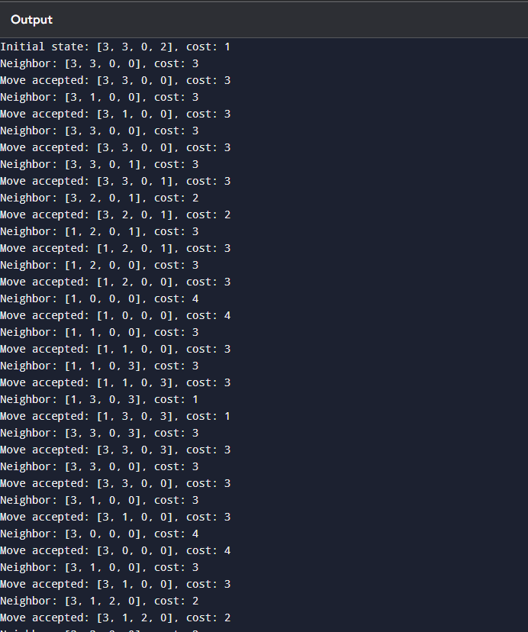

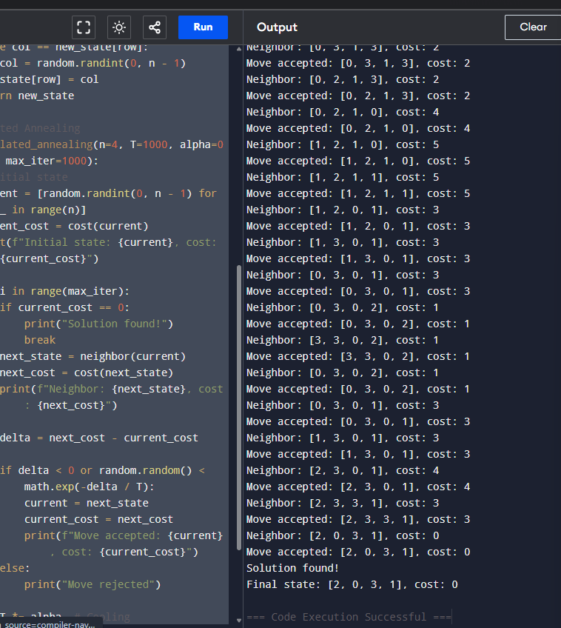

SIMULATED ANNEALING 8 QUEENS:  
import random

import math

# ---------- Helper Functions ----------

def random_state(n=8):

return [random.randint(0, n-1) for _ in range(n)]

def heuristic(state):

"""Number of attacking pairs of queens (lower = better)."""

attacks = 0

n = len(state)

for i in range(n):

for j in range(i + 1, n):

if state[i] == state[j] or abs(state[i] - state[j]) == abs(i - j):

attacks += 1

return attacks

def random_neighbor(state):

"""Move one queen to a new random row."""

n = len(state)

neighbor = state[:]

col = random.randint(0, n - 1)

new_row = random.randint(0, n - 1)

while new_row == neighbor[col]:

new_row = random.randint(0, n - 1)

neighbor[col] = new_row

return neighbor

# ---------- Simulated Annealing ----------

def simulated_annealing(n=8, initial_temp=100.0, cooling_rate=0.99):

current = random_state(n)

T = initial_temp

print("Initial State:", current)

print("Initial Cost:", heuristic(current))

print("--------------------------------------")

while T > 0.001:

h_current = heuristic(current)

if h_current == 0:

break

neighbor = random_neighbor(current)

h_neighbor = heuristic(neighbor)

deltaE = h_current - h_neighbor

if deltaE > 0 or math.exp(deltaE / T) > random.random():

current = neighbor

T *= cooling_rate

print("Final State:", current)

print("Final Cost:", heuristic(current))

# ---------- MAIN ----------

simulated_annealing(8)

OUTPUT:

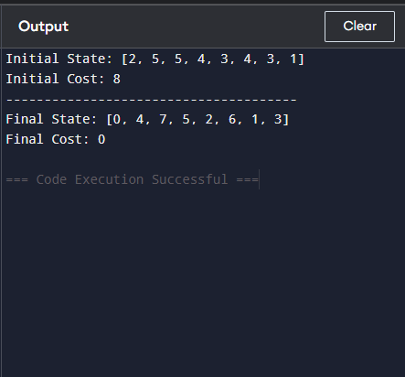

A* 8 PUZZLE

from heapq import heappush, heappop

# Goal state

goal_state = [[1, 2, 3],

[4, 5, 6],

[7, 8, 0]] # 0 represents the empty space

# Function to find position of a number in the puzzle

def find_pos(state, value):

for i in range(3):

for j in range(3):

if state[i][j] == value:

return (i, j)

# Heuristic: Manhattan distance

def manhattan(state):

dist = 0

for i in range(3):

for j in range(3):

if state[i][j] != 0:

x, y = find_pos(goal_state, state[i][j])

dist += abs(x - i) + abs(y - j)

return dist

# Convert list of lists to a tuple (so it can be stored in sets)

def state_to_tuple(state):

return tuple(sum(state, []))

# Generate next possible moves

def get_neighbors(state):

neighbors = []

i, j = find_pos(state, 0) # blank position

moves = [(-1,0), (1,0), (0,-1), (0,1)] # up, down, left, right

for dx, dy in moves:

x, y = i + dx, j + dy

if 0 <= x < 3 and 0 <= y < 3:

new_state = [row[:] for row in state]

new_state[i][j], new_state[x][y] = new_state[x][y], new_state[i][j]

neighbors.append(new_state)

return neighbors

# A* algorithm

def a_star(start):

open_list = []

heappush(open_list, (manhattan(start), 0, start, [])) # (f, g, state, path)

visited = set()

while open_list:

f, g, current, path = heappop(open_list)

if current == goal_state:

return path + [current]

visited.add(state_to_tuple(current))

for neighbor in get_neighbors(current):

if state_to_tuple(neighbor) not in visited:

heappush(open_list, (g + 1 + manhattan(neighbor), g + 1, neighbor, path + [current]))

return None

# Print the puzzle state nicely

def print_state(state):

for row in state:

print(row)

print()

# Example initial state (you can change this)

start_state = [[1, 2, 3],

[4, 0, 6],

[7, 5, 8]]

print("Initial State:")

print_state(start_state)

print("Solving...\n")

solution = a_star(start_state)

if solution:

print("Solution found in", len(solution)-1, "moves:\n")

for step in solution:

print_state(step)

else:

print("No solution found.")

OUTPUT:

